

EC22377A
Datasheet

V 1.8

Contact Us:

Web: http://www.ecotron.ai
Email: info@ecotron.ai
support@ecotron.ai

Address: 2942 columbia street
Torrance, CA 90503
United States

Tel: +1 562-758-3039
+1 562-713-1105

Table of Contents
Chapter 1 System Introduction 2
1.1 VCU Introduction 3
1.1.1 Functions 3
1.1.2 Mechanical Properties 3
1.1.3 Connectors 5
1.1.4 Tech Specs 7
1.1.5 Recommended Software Tools 7
1.1.6 Power Supply 7
1.1.7 Description of Bootloader 7
Chapter 2 Technical Performance 7
2.1 Electrical Characteristic Parameters 8
2.2 Electrical Performance Test Standards 8
2.3 Environmental Test Standards 9
2.4 EMC Test Standards 10
Chapter 3 Installation Requirements 11

System Introduction

VCU Introduction
VCU (Vehicle Control Unit) is the master controller for electric vehicles.
The VCU receives the driver's input signals, such as pedal signals, vehicle speed signals, gear signals, and other input signals. The VCU coordinates the motor, battery pack, and other accessory systems to meet the driving torque requirements. The VCU realizes fault diagnosis and processing, vehicle status monitoring, vehicle mode conversion and other functions.
The VCU is the vehicle network control or main control unit based on CAN bus network.

Functions
EC22377A has the following functions:
Functions
1 – Key signal (KEYON)
1 – Hard-wired wake-up signal (WAKEUP)
2 – Supply voltage (BATT)
4 – 5V output
4 – CAN communication interface: supports CAN flashing, CAN1 supports specific frame wake-up
1 – LIN communication interface, only supports host mode.
1 – RS232 communication interface
1 – PLC communication interface
1 – 10/100Mbps Automotive Ethernet interface
2 – H-bridge output
16 – Analog signal input, 2 for PT1000 input, AI15 reserved
18 – Digital signal input
6 – Frequency signal input
10 – High-side driver control output, 6 configurable for PWM
20 – Low-side driver control output, 8 configurable for PWM
PLC – CP, PP, PE output (optional)
Hardware watchdog

Mechanical Properties
The housing of the VCU is die-cast aluminum and assembled with a silicone seal. There is no special treatment or plating on the outside of the housing, no sharp burrs, and sharp edges.
The nominal dimensions of the housing shape of the VCU are as follows (excluding the female end of the VCU connector, in mm):
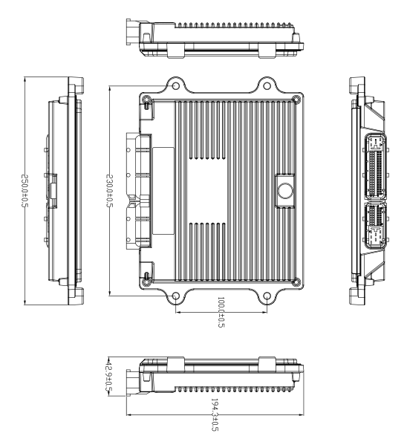
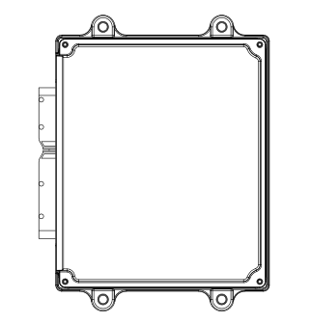
The appearance of the housing is as follows:
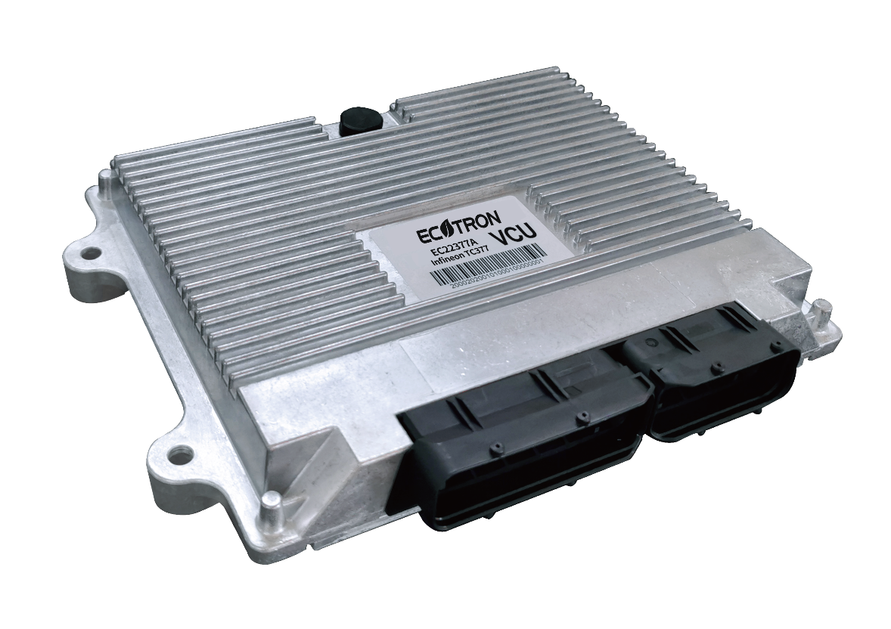
Please use Torx T15 screwdriver to disassemble and assemble the housing.
The VCU housing is affixed with a product identification label containing the product identification code, including customer information, production date, batch number, serial number, etc.

Connectors
Ecotron VCU, shown below, uses automotive grade connectors from TE, which meet the automotive safety requirements and have 121 pins. The specific models of the connector kits are shown in the table below. Customers can contact Ecotron to purchase full harnesses or male connector kits.
# | Name | Part Number | Supplier | URL
1 | PCB Mount Header | 1746979-1 | TE | https://www.te.com/usa-en/product-1746979-1.html
2 | 81P Housing for Female Terminals | 1473244-1 | TE | https://www.te.com/usa-en/product-1473244-1.html
3 | 40P Housing for Female Terminals | 1473252-1 | TE | https://www.te.com/usa-en/product-1473252-1.html
4 | 81P Connector Caps & Covers | 1473247-1 | TE | https://www.te.com/usa-en/product-1473247-1.html
5 | 40P Connector Caps & Covers | 1473255-1 | TE | https://www.te.com/usa-en/product-1473255-1.html
6 | 81P Connector Clip | 368382-1 | TE | https://www.te.com/usa-en/product-368382-1.html
7 | 40P Connector Clip | 368388-1 | TE | https://www.te.com/usa-en/product-368388-1.html
8 | Terminals, Receptacle, Mating Tab Width .025 in [.63 mm] >0,2-0,35 | 5-968220-1 | TE | https://www.te.com/usa-en/product-5-968220-1.html
9 | Terminals, Receptacle, Mating Tab Width .11 in [2.8 mm] 0,5-0,75 | 5-968221-1 | TE | https://www.te.com/usa-en/product-5-968221-1.html
10 | Terminals, Receptacle, Mating Tab Width .11 in [2.8 mm] 0,75-1,0 | 964286-2 | TE | https://www.te.com/usa-en/product-964286-2.html
11 | Terminals, Receptacle, Mating Tab Width .11 in [2.8 mm] 1,5-2,5 | 964273-2 | TE | https://www.te.com/usa-en/product-964273-2.html

The connector diagram is as follows:
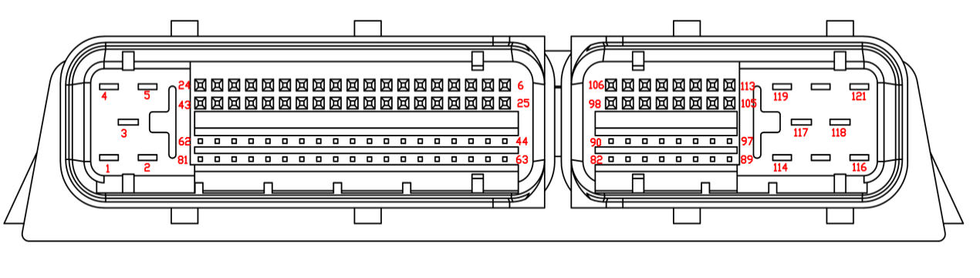 Figure: Connector Kit and Pin Distribution Diagram

Tech Specs

Feature | Detail
Micro Control Core | 32-bit SAK-TC377TP-96F300S AA
Maximum Frequency | 300MHz
Flash | 6M
SRAM | 1.1M
Float Point Capability | Yes

Recommended Software Tools
Controller | EC22377A
Main Chip | SAK-TC377TP-96F300S AA
IDE | HighTec Tricore Tool Chain
EcoCoder Version | EcoCoder-v2.9.12 R7 and above
EcoFlash Version | EcoFlash-v1.1.6.7 and above
EcoCAL Version | EcoCAL-V2.1.8.3 and above

Power Supply
The EC22377A requires two continuous power supplies (PIN1, PIN3) to power on the VCU via a key switch (PIN42).
A 5A fuse in series with PIN1 and PIN3 are recommended for EC22377A power supply.

Description of Bootloader
The EC22377A bootloader supports the UDS protocol by default.

Technical Performance

Electrical Characteristic Parameters
Characteristic | Design Specification
Operating Voltage | DC 12/24V (9~32V)
Operating Temperature | -40~85 °C
Operating Humidity | 0~95%, no condensation
Storage Temperature | -40~85 °C
Quiescent Current | ≤3mA
Rated Power Consumption | 3W (not including load power)
Protection Level | IP67
Weight | ≤1150g
Dimensions | 250×194×42mm
Housing Material | Die-cast Aluminum
Housing Characteristics | Equipped with waterproof ventilation valve, good heat dissipation

Electrical Performance Test Standards
Item | Test Standard
DC Supply Voltage | ISO 16750-2
Overvoltage (12V, high temperature) | ISO 16750-2
Supply Voltage Ramp Down and Ramp Up | ISO 16750-2
AC Voltage Superposition Test | ISO 16750-2
Reverse Voltage | ISO 16750-2
Low Voltage Reset Feature | ISO 16750-2
Low Voltage Startup Feature | ISO 16750-2
Open Circuit Experiment - Single-Line Interruption | ISO 16750-2
Open Circuit Experiment - Multi-Line Interruption | ISO 16750-2
Short Circuit Protection | ISO 16750-2
Withstand Voltage | ISO 16750-2
Insulation Resistance | ISO 16750-2

Environmental Test Standards
Item | Test Standard
Waterproof (IP67) | IEC/EN 60529
Dustproof (IP67) | ISO 20653
Salt Spray Leak Function and Corrosion Test | ISO 16750-4
Mechanical Vibration Shock Test | ISO 16750-3
Vibration Test | ISO 16750-3
Drop Test | ISO 16750-3
Temperature Shock | ISO 16750-4
Electrical Operation at Cycling Ambient Temperatures | ISO 16750-4
High and Low Temperature Operation Experiment | ISO 16750-4
High and Low Temperature Experiment | ISO 16750-4
Temperature and Humidity Cycle | IEC 60068-2-30
Constant Temperature and Humidity | ISO 16750-4

EMC Test Standards
Item | Test Standard
Transient Conducted Emission | ISO 7637-2
Conducted Emission Experiment CE-V | CISPR25
Conducted Emission Experiment CE-C | CISPR25
Radiation Emission Experiment RE-ALSE Method | CISPR25
Radiation Immunity Test (I/O)-ICC Method | ISO 7637-3
Radiated Immunity Test BCI-substitution Method | ISO 11452-4
Radiation Immunity Experiment RI | ISO 11452-2
Low Frequency Magnetic Field Immunity | ISO 11452-8
Electrostatic Discharge (ESD) | GMW3097

Installation Requirements
It is recommended to install the VCU in the cockpit. If the OEM wants to assemble the VCU in another location, Ecotron’s engineers and the OEM’s engineers should evaluate the corresponding installation location together.
Precautions for VCU installation are as follows:
1) The installation of VCU and harness shall be firm and reliable without looseness, and please avoid supporting the harness through VCU. At the same time, the layout of VCU harness shall prevent and protect all wires in the harness from damage due to wear and overheating.
2) Try to avoid installing it in the place where dust is easy to gather. A large amount of dust accumulation will affect the reliability of VCU work.
3) It shall be kept away from the position where the temperature of its shell may exceed 85 ° C as far as possible, and the heat released by surrounding parts shall be prevented from radiating to VCU.
4) Avoid installing VCU in places where oil, moisture and water droplets are easy to splash.
5) Avoid the possibility of additional mechanical vibration and external force impact due to the installation position and fixing method of VCU and avoid installing VCU at the resonance point of vehicle body.
6) Avoid installing the VCU near the parts that may contact the battery or other acid-base solutions that are easy to seep out, and the places where the VCU is easy to be corroded.
7) Avoid installing the VCU near the positive terminal of the battery and the terminal of the ignition power supply.
8) The VCU shall be installed at a certain angle to avoid the inflow of water from the connector. In the horizontal direction, the recommended installation angle is - 170 ° to - 10 °. In the vertical direction, the recommended installation angle is - 170 ° ~ - 10 °. As shown in the figure below.
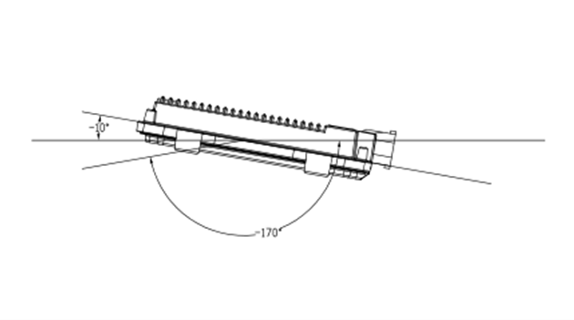
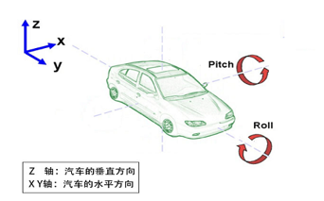
Z Axis : Vertical Direction
X Y Axes : Horizontal Direction
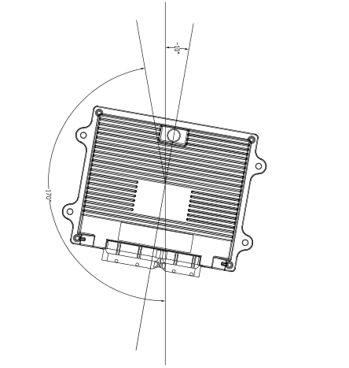
ECOTRON recommends using the four mounting holes on the VCU for installation. It is recommended to use metal materials such as aluminum alloy for the mounting bracket. The housing should have a reliable electrical connection with the vehicle body through the bracket. If other materials are used, the customer must ensure that they can meet the requirements of VCU for vibration, heat dissipation, temperature, EMC, etc. If there is any deviation, it needs to be confirmed with ECOTRON.
The VCU system connects to the ground through the vehicle’s body. The specific requirement is to directly connect the ground wire in the wiring harness to the vehicle’s body and ensure reliable electrical connections.
Mechanical Installation Recommendations: (Users can modify according to their vehicle requirements)
Recommended screw specifications for installation: M6 nut, M6*25 screw.
Recommended tightening torque: 7 N·m.
Recommended dimensions and parameters for additional vibration-damping pads: inner diameter 6mm, outer diameter 20mm, thickness 15mm.

